Extended abstract title [Times New Roman 9 pt bold, style ‘Title’]

F. A. Author1,a, S. B. Author2, T. Author1,3 [Times New Roman 9 pt regular, style ‘Authors’]

1Department, Institution/Organization, Place (e.g., City, State), Country [Times New Roman 8 pt italic, style ‘Affiliation’]

2Department, Institution/Organization, Place (e.g., City, State), Country [Times New Roman 8 pt italic, style ‘Affiliation’]

3Department, Institution/Organization, Place (e.g., City, State), Country [Times New Roman 8 pt italic, style ‘Affiliation’]

aPresent address: Department, Institution/Organization, Place (e.g., City, State), Country (For any author whose present address differs from that at which the work was done) [Times New Roman 8 pt italic, style ‘Present Address’]

Corresponding author: First_name Family_name. Email: name@organization.com [Times New Roman 9 pt regular, style ‘Authors’]

***Keywords: [Times New Roman 9 pt bold italics]*** Keyword A, Keyword B, Keyword C [Times New Roman 9 pt regular, style ‘Normal’]

# Implications [Times New Roman 9 pt bold italics, style ‘Heading 1’]

100 word maximum. [Times New Roman 9 pt regular, style ‘Normal’]

# Level 1 Heading [Times New Roman 9 pt bold italics, style ‘Heading 1’]

Body text. [Times New Roman 9 pt regular, style ‘Normal’]

For example, here is the equation for the area of a circle (Equation 1). Press Enter to go to the next line, then select style ‘Equation’. On the new line, press tab to center justify, Insert Equation with built-in Equation Editor, then right arrow to get out of the equation editor box, then tab, then add the equation number.

$A=πr^{2}$ (1)

Where, *A* is the area (m2) of a circle, *π* is 3.141 and *r* is the radius (m).

Next is an example for a table (Table 1). The table should span the entire page width. Table Layout > AutoFit > AutoFit Window. The top and bottom (above table superscript definition cell) horizontal lines should be 1 pt thick (black) and any other interior horizontal lines should be ½ pt thick lines (black).

**Table 1.[Times New Roman 9 pt bold]** This is the caption for my table. [Times New Roman 9 pt regular, style ‘Normal’]

|  |  |  |  |
| --- | --- | --- | --- |
| [Times New Roman 9 pt regular, style ‘No Spacing’] | Column Headinga | Column Heading | Column Heading |
| Row Heading | Number | Number | Number |
| Row Heading | Number | Number | Number |
| Row Heading | Number | Number | Number |
| a superscript definition [Times New Roman 8 pt regular, style ‘Table Footnote’]  Delete this text and leave a blank line here. | | | |

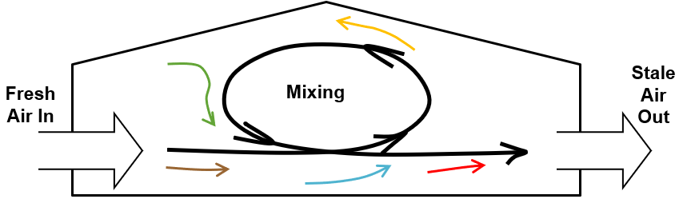Next is an example for a figure (Fig. 1). Text wrapping should be Top and Bottom (i.e., there shall be no text on the sides of the figure) and figure should be center aligned.

**Fig. 1.[Times New Roman 9 pt bold]** This is the caption for my figure. [Times New Roman 9 pt regular, style ‘Normal’]

# References [Times New Roman 9 pt bold italics, style ‘Heading 1’]

Maximum of 8 references! [Times New Roman 9 pt regular, style ‘Normal’]

Author, A., Author, D., Year. Chapter title. In Book title (ed. Editor, A.B., Editor, C.D.). Publisher name, place of publication (i.e. city, state (if applicable) and country), pp. first page-last page numbers

Author, A., Author, B., Author, C.-D., Author, E., Year. Title of article. Full Name of the Journal Volume number, first page-last page numbers.

Author, A., Author, N., Author, C.A.B., Author, M., Year. Title of communication. Proceedings of the conference title, date of the conference (i.e. day month year), place of the conference (i.e. city, state (if applicable) and country), first page-last page numbers or poster/article number.

Author, A.B., Year. Title of article. Full Name of the Journal Volume number, first page-last page numbers.

Author, C., Author, B., Author, A.D., Author, E., Year. Title of book. Publisher name, place of publication (i.e. city, state (if applicable) and country).

Author, C., Author, B., Author, A.D., Author, E., Year. Title of communication. In Name of the meeting or symposium (ed. Author, A., Author, B.C., Author, D.). Publisher name, place of publication (i.e. city, state (if applicable) and country), pp. first page-last page.

Author, M., Year. Title of thesis. Type of thesis, University with English name, location of the University (i.e. city, state (if applicable) and country).

Author, M., Author, J., Author, P.E., Author, D., Year. Document title. Retrieved on date month year from full URL address of the web page.

Author, M., Author, N., Author, A.B., Author, M., Year. Title of paper. Paper presented at the nature of the event, date of the event (i.e. day month year), place of the event (i.e. city, state (if applicable) and country), pages (if applicable).